**Name: Shivam Mishra**

**Roll no.: B135**

**Admission no.: U20CS135**

**AI Assignment-2**

**1. Identify and remove the errors/suggestions in the given knowledge base.**

Ans.

male(motilal).

male(javaharlal).

male(firoz).

male(sanjay).

male(rajiv).

male(varun).

male(rahul).

male(ranjit).

female(swarupmati).

female(kamla).

female(indira).

female(menka).

female(sonia).

female(priyanka).

female(vijyalakshmi).

female(tara).

female(lekha).

female(rita).

female(krishna).

parent(motilal,javaharlal).

parent(motilal,vijyalakshmi).

parent(motilal,krishna).

parent(swarupmati,javaharlal).

parent(swarupmati,vijyalakshmi).

parent(swarupmati,krishna).

parent(javaharlal,indira).

parent(kamla,indira).

parent(indira,sanjay).

parent(firoz,sanjay).

parent(indira,rajiv).

parent(firoz,rajiv).

parent(sanjay,varun).

parent(menka,varun).

parent(rajiv,rahul).

parent(rajiv,priyanka).

parent(sonia,rahul).

parent(sonia,priyanka).

parent(vijyalakshmi,tara).

parent(vijyalakshmi,lekha).

parent(vijyalakshmi,rita).

parent(ranjit,tara).

parent(ranjit,lekha).

parent(ranjit,rita).

**2. Generate rules of following relations in considering the given knowledge**

**base:**

**a. grandparent/2.**

**b. brother/2.**

**c. sister/2.**

**d. uncle/2.**

**e. aunt/2.**

**f. mother/2.**

**g. father/2.**

**h. wife/2.**

**i. child/2.**

**j. son/2.**

**k. daughter/2.**

Ans.

father_of(X,Y):- male(X),parent(X,Y).

mother_of(X,Y):- female(X),parent(X,Y).

wife_of(X,Y):- father_of(X,Z),mother_of(Y,Z).

grandparent_of(X,Y):- parent(X,Z),parent(Z,Y).

brother_of(X,Y):- male(X),father_of(P,X),father_of(P,Y),X\=Y.

sister_of(X,Y):- female(X),father_of(P,X),father_of(P,Y),X\=Y.

uncle_of(X,Y):- parent(P,Y),brother_of(P,X).

aunt_of(X,Y):- parent(P,Y),sister_of(P,X);wife_of(Z,X),uncle_of(Z,Y).

child_of(X,Y):- parent(Y,X).

son_of(X,Y):- male(X),parent(X,Y).

daughter_of(X,Y):- female(X),parent(X,Y).

cousin_of(X,Y):- uncle_of(P,Y),child_of(X,P);aunt_of(A,Y),child_of(X,A).

**3. Answer the following queries**

**a. Find all females in the given tree**

q1(X):- female(X).

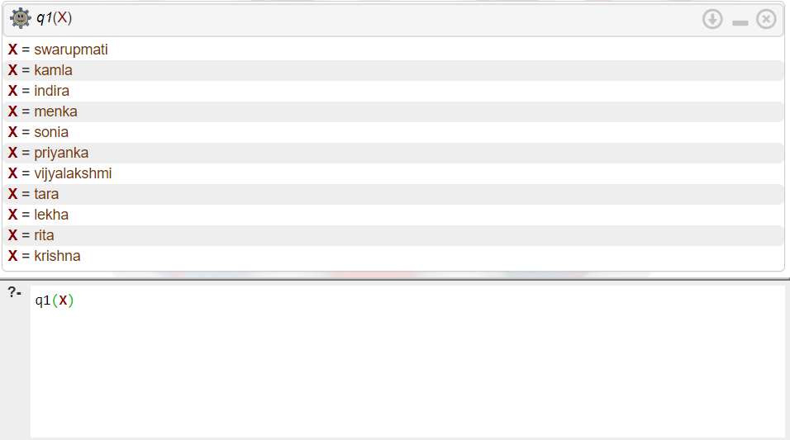

**b. How many grandchild do motilal have?**

q2(X):- grandparent_of(motilal,X).

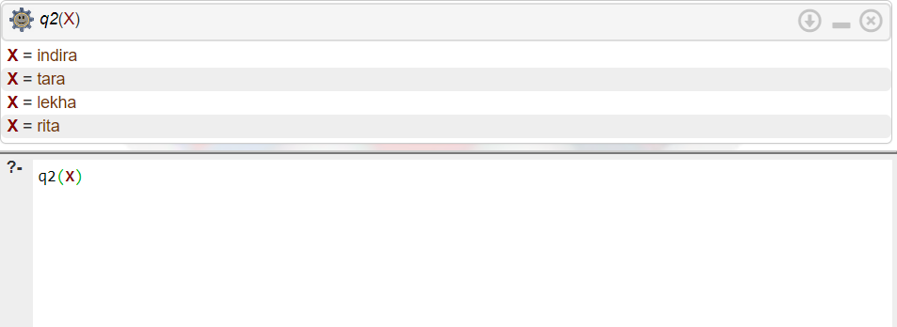

**c. Who is/are sister of lekha?**

q3(X):- sister_of(X,lekha).

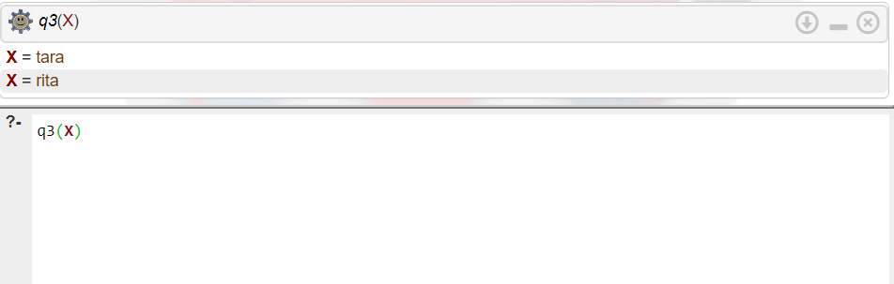

**d. Who are parents of tara?**

q4(X):- parent(X,tara).

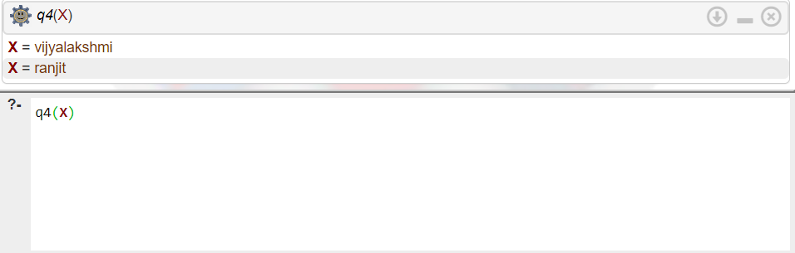

**e. Who are cousins of rajiv?**

q5(X):- cousin_of(X,rajiv).

